**DEPARTMENT OF ELECTRONICS & COMMUNICATION ENGINEERING**



Embedded System

**Experiment-11**

**­­**

**Submitted by**

**PRATIBHA SINGH**

**602162015**

**M.Tech (VLSI Design)**

**­­­**

**Experiment 11**

**Aim:**

To write an ARM Assembly Language to find the length of a string.

**Tool Used:**

Keil uVision4

**Theory:**

DCD stands for Define Constant Double word and DCB stands for Define Constant Byte. The value of the string is loaded using DCB and DCD values and compared until the value is 0.

**Code:**

    AREA PROGRAM, CODE, READONLY

    ENTRY

MAIN

        LDR R0, VALUE1

LOOP2   LDRB R3,[R0],#1

        ADDS R3,R3,#0

        BEQ LOOP1

        ADD R7,R7,#1

        B LOOP2

LOOP1   ADD R0,R0,#0

    AREA PROGRAM, DATA, READONLY

VALUE1 DCD STRING

STRING DCB "EMBEDDED SYSTEM"

    END

**Output:**

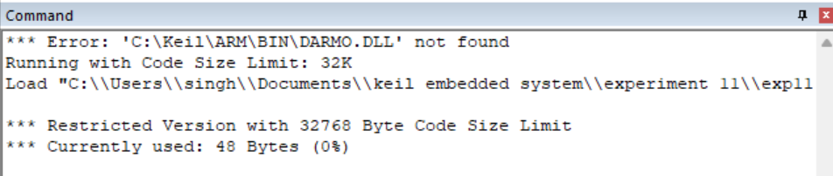

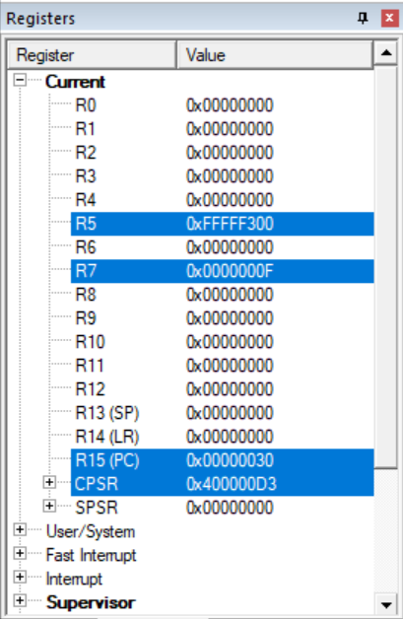

The word Embedded System is having F characters which are displayed in R7.

**Result:**

The experiments to find the length of a string have been performed and verified to be correct